**Project part assign to Faris for  IT228 Capstone**

**Comprehensive Rental Management System (CRMS) Project**

North Greenlake / Licton Springs Rental

[Home](http://docs.google.com/index.html) Login Payment Gateway [Small Meeting Space](http://docs.google.com/Small_Meeting_Space.html) [Solo Worker Space](http://docs.google.com/Solo_Worker_Space.html) [Short Term and Extended Stay](http://docs.google.com/Short_Term_and_Extended_Stay.html)

[Overview](https://docs.google.com/document/d/1uAzXTLVg8faM4L9rCNFpEL90rUyDmQiPkYMSs0CY4a8/edit#bookmark=id.gjdgxs) | [Amenities](https://docs.google.com/document/d/1uAzXTLVg8faM4L9rCNFpEL90rUyDmQiPkYMSs0CY4a8/edit#bookmark=id.30j0zll) | [Rates](https://docs.google.com/document/d/1uAzXTLVg8faM4L9rCNFpEL90rUyDmQiPkYMSs0CY4a8/edit#bookmark=id.1fob9te) | [Fees](https://docs.google.com/document/d/1uAzXTLVg8faM4L9rCNFpEL90rUyDmQiPkYMSs0CY4a8/edit#bookmark=id.3znysh7) | [Terms](https://docs.google.com/document/d/1uAzXTLVg8faM4L9rCNFpEL90rUyDmQiPkYMSs0CY4a8/edit#bookmark=id.2et92p0) |

Overview

Description

Our attractive, fully equipped conference rooms and business meeting rooms provide an ideal working environment. They include state-of-the-art equipment and capabilities plus free WIFI and free local and long distance calls. And all our meeting facilities come with a thoroughly trained, professional support staff.

AMENITIES Free Parking, Interior, Internet Connection (Wired), Water Service, WiFi-Wireless Internet Connection, Writing/White Board, Flat Screen TV

LOCATION We are 30 minutes away from the Seattle Tacoma Airport. There is an abundance of free, entry level parking, as well as plenty of buses and ride share that make getting around simpler and quicker.

The Canyon Park Shopping Center is the nearest cluster of retailers and there are multiple eateries nearby or within walking distance. The building is not far from the University of Washington. There are also several nature trails in the area including the Sammamish River Trail and the North Creek Trail.

PARKING Free parking

HOURS Open during business hours from 8:00 a.m. to 5:00 p.m. with professional receptionists to greet guests.

Features

Bedrooms: 2

Bathrooms: 1

Square Feet: variable

Furnished: Yes

Property Type: Short Term and Extended Stay

Property Setup:Home

Minimum Stay: 4 hours (meeting space) to 1+ Month

Entry Floor: 1

Pets: No

Smoking: No

Managed by

First Name: Yen

Relation to Property: Property Manager

Amenities

Air Conditioning

Heating

Washer/Dryer in Building

WiFi

Cable

Streaming Service Included

Parking: On-Street Parking

Alarm System

Carbon Monoxide Alarm

Smoke Alarm

Rental Rates

$2500 one bed room Per Month

$3500 one bed room Per Month

Fees and Details

Security Deposit: $2000

(Refundable)

Cleaning Fee: $250

(One Time Fee)

Background and Credit Check Fee: $42

(One Time Fee per applicant 18+)

Terms and Details

Move-in ready: high speed WIFI– no need to set up separate electric, gas, water, accounts!

$3000 PER MONTH (3 MONTH MINIMUM REQUIREMENT)

Amenities included:

Central Air condition

Internet

Appliances

Furnished

On site laundry (washer/dryer)

NO pets policy

Rental Requirements:

* *SINGLE occupancy
* *Verifiable rental history
* *Pass a background check
* *Deposit ONE MONTH'S RENT
  + $ 50.00 Application fee
  + 2 forms of ID required
  + Deposit

First month's rent required to move in

Credit score of 700 or higher (or above 670 with verified income of 3.5x monthly rent),

No open bankruptcies

No past landlord-tenant disputes

No evictions in the last 7 years

Log in to Property manager

Customer information’s that the rental office required

OVERVIEW

Description

ALL UTILITIES PAID: Enjoy spending time in Austin when you book a home featuring a luxury oasis view with a pool and guest house. The main home has two stories, while the casita has a private entrance. The larger home has four bedrooms, four bathrooms, an executive office overlooking the pool, and spacious dining and living areas. The casita has a one-bedroom studio with a full kitchen, a living area, and an executive office.  
  
This elegant mid-term corporate home is located on a one-acre lot on a peaceful cul-de-sac with gorgeous greenbelt views. It’s also in the highly rated Leander school district, which is top rated in the State of Texas.  
  
With a flexible lease of three to 12 months, you can enjoy a fully furnished space with items like linens and kitchenware provided. The area of the home is family-friendly with a safe and welcoming atmosphere, making it ideal for anyone needing a temporary space while renovating or building.  
  
Located only 22 miles from downtown in Northwest Austin, the luxury oasis view with a pool and guest house includes all utilities, high-speed Internet, lawn maintenance, quarterly pest control, AC filter replacement, and monthly pool service. It’s a fully move-in-ready experience to avoid any hassle on your end.  
  
This corporate home's outdoor living space is perfect for entertainment and relaxation. It offers a fire pit, a heated plunge pool, and seating near fantastic landscaping. Unwind in the hot tub or infinity pool while you enjoy greenbelt views.  
  
Inside this luxury oasis view with a pool and guest house, you’ll find stylish décor and modern amenities to create an elegant but comfortable environment. From the cozy living areas to the well-equipped kitchen, the entire home is designed to enhance your living experience.  
  
This home is near Austin’s technology hub, where you can access employers like Apple, Google, 3M, Tesla, Cisco Systems, Cirrus Logic, Oracle, Hewlett-Packard, Bioware, Intel, Samsung, Silicon, National Instruments, Applied Materials, and United Devices.  
  
Hospitals nearby:  
--Family Hospital at Lake Travis 10 mins  
--Ascension Seton Northwest Hospital 22 mins  
--Baylor Scott & White Medical Center 23 mins  
  
--Only 25 minutes from downtown Austin.  
--35 mins to Austin-Bergstrom International Airport  
  
Oversized 2 car garage available with plenty of parking.  
No smoking and the acceptance of pets is negotiable with the property manager.

**Here are starting webpages coding & website screen shoot documents**

[**Home**](http://docs.google.com/index.html) **page code**

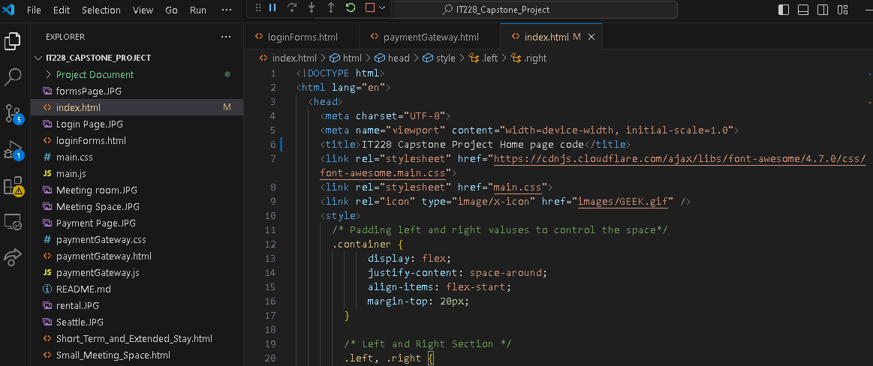

1. [**Home**](http://docs.google.com/index.html) **page website**

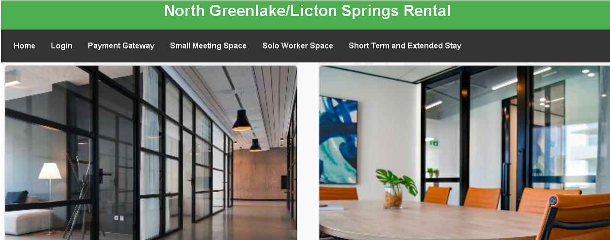

THIS OVERVIEW OF THE PAGES

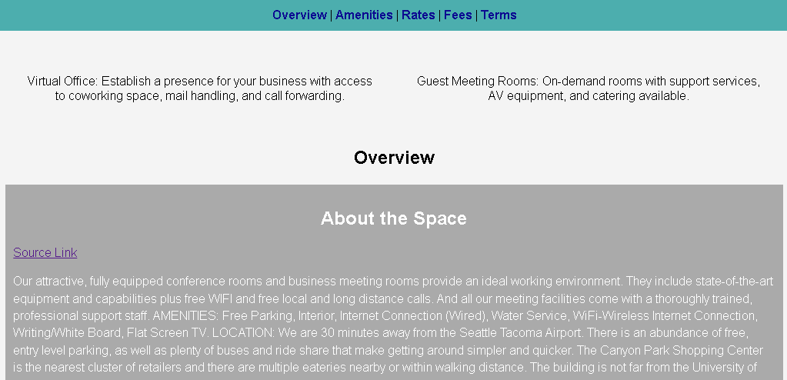

Features of the Rental Rooms

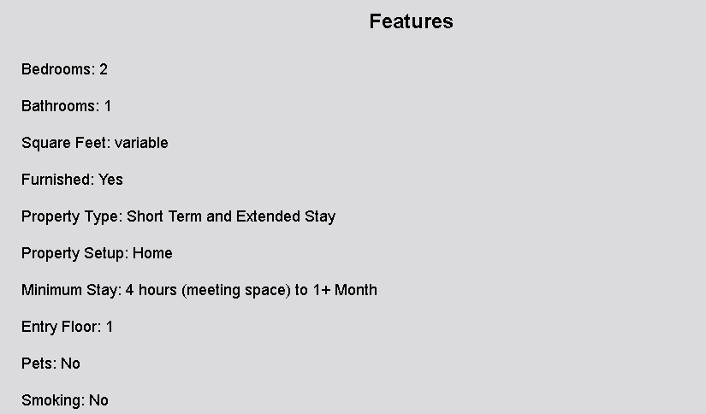

Services available

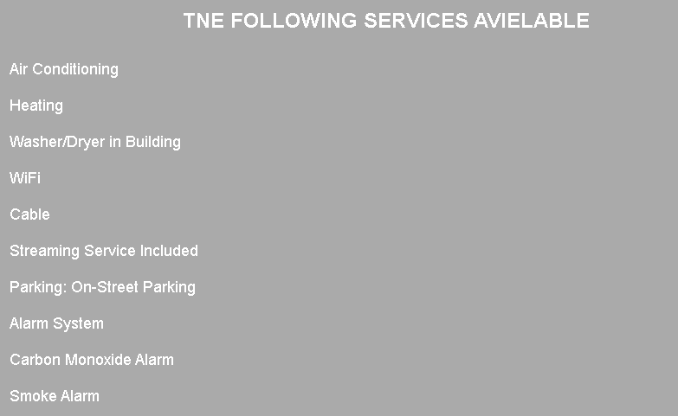

Rant rate and fees

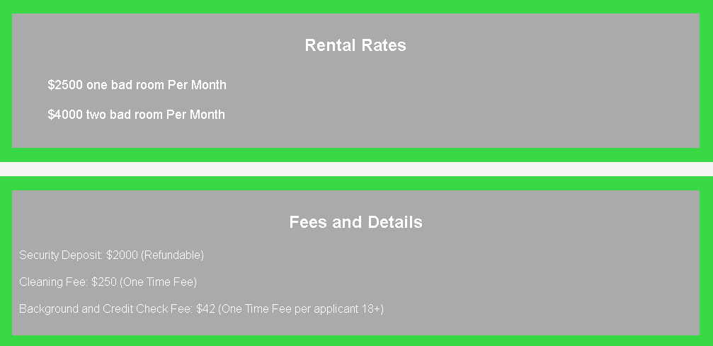

Terms and details

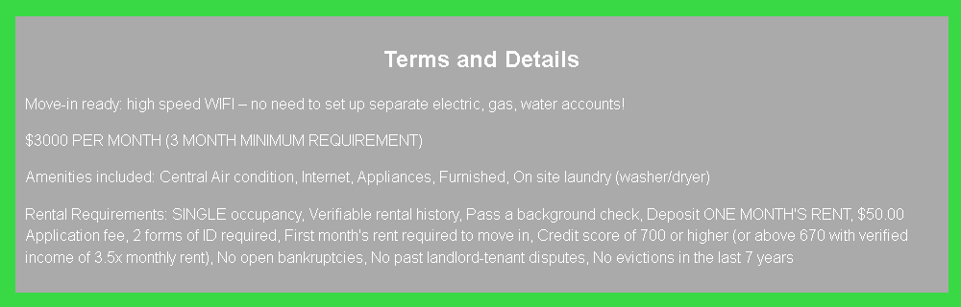

**Click a link above in about the spaces to see the Home page websites**

1. **Login Code for (CRMS)**

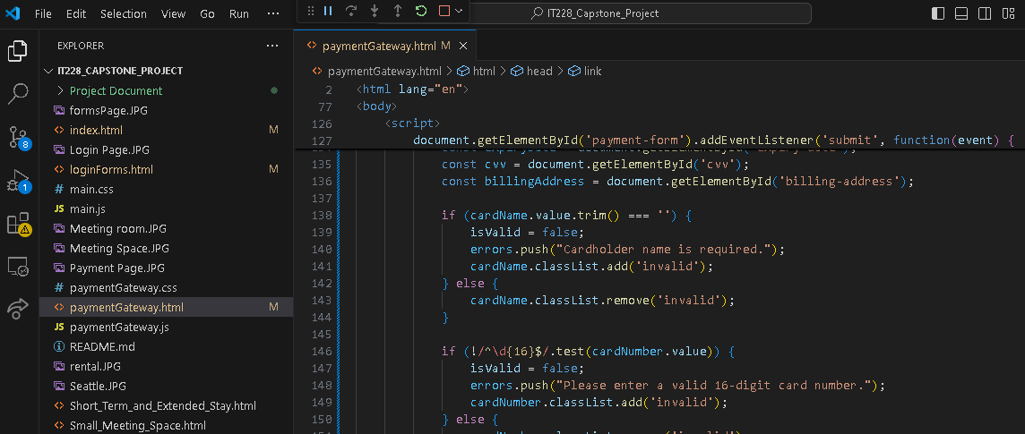

**Login page screen shoot of Comprehensive Rental Management System (CRMS)**

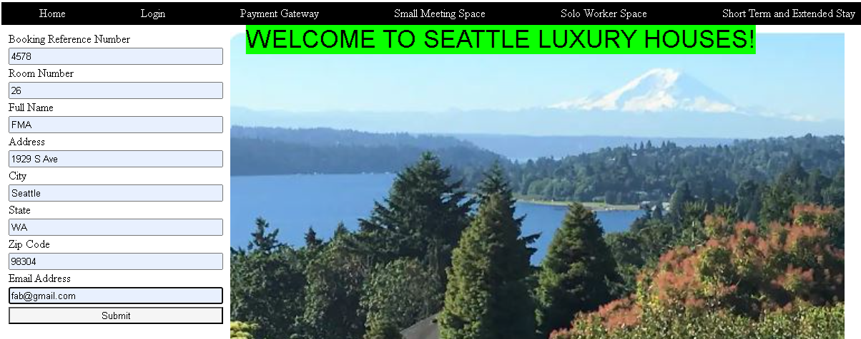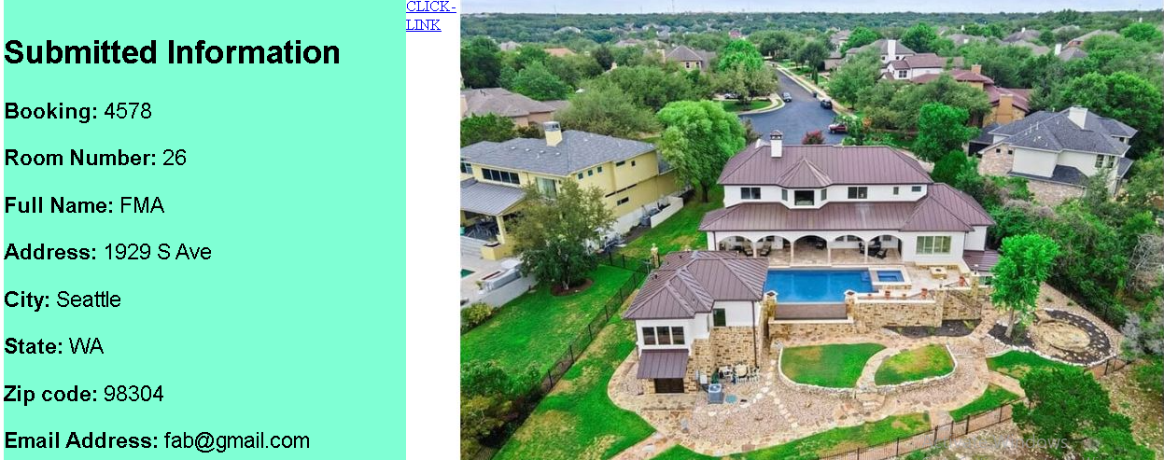

**Here’s linked website**

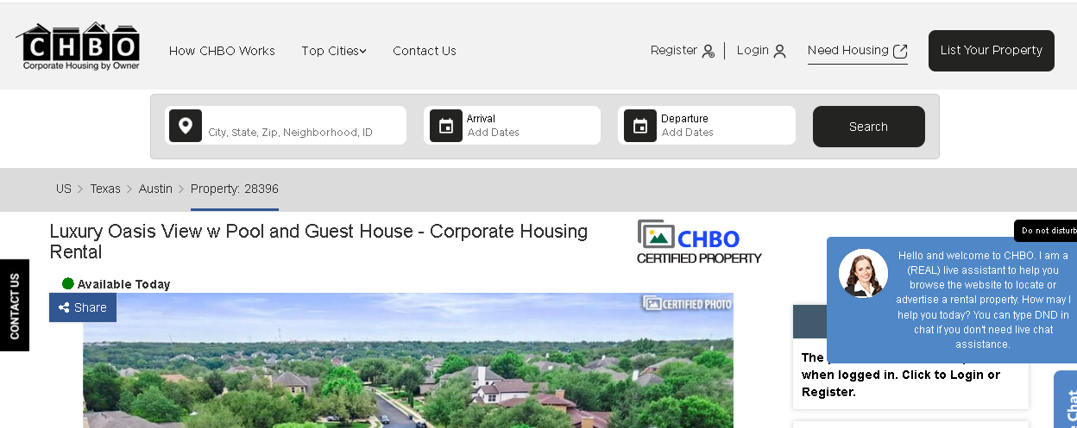

1. **Payment Gateway of****Comprehensive Rental Management System (CRMS)**

*Coding and Websites page screen shoot*

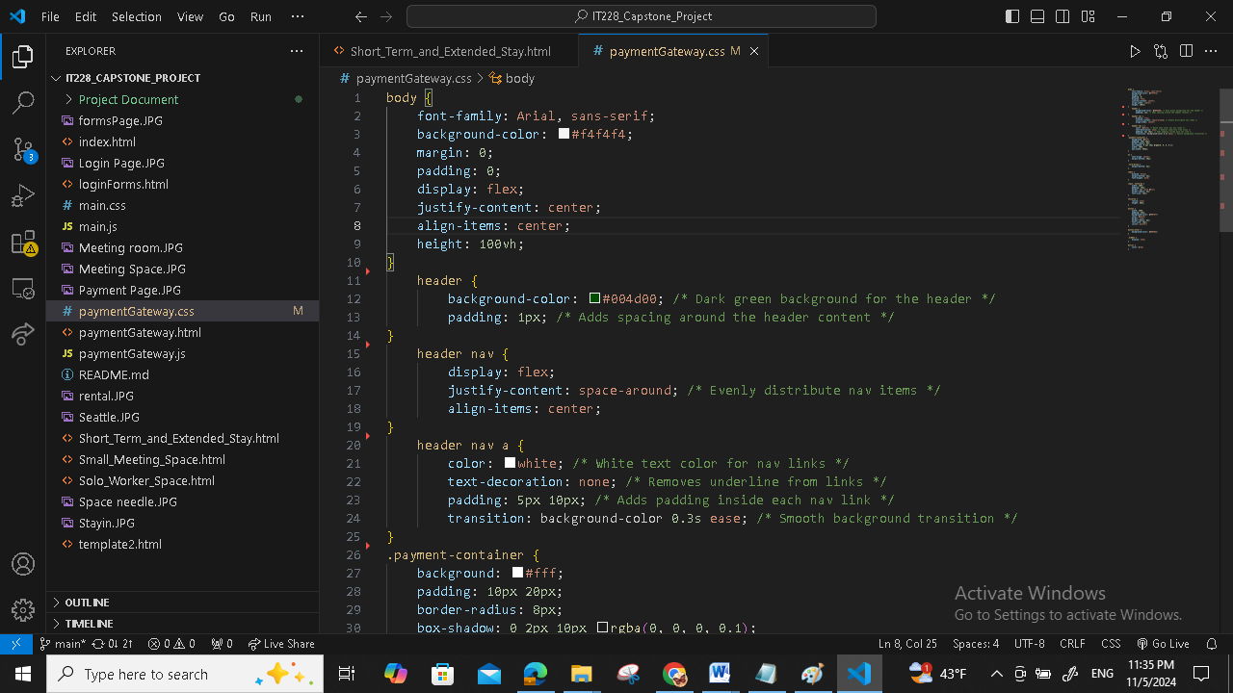

**This error message validation and proper handling of error and success messages**

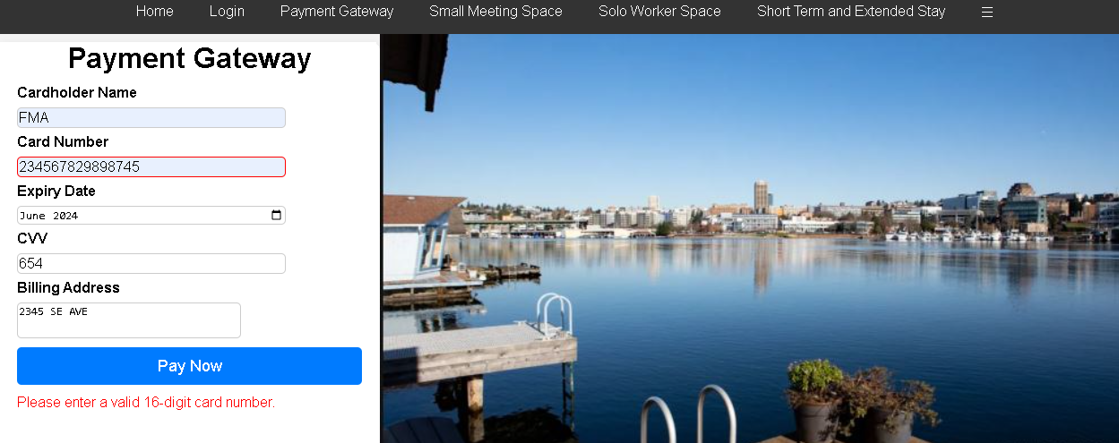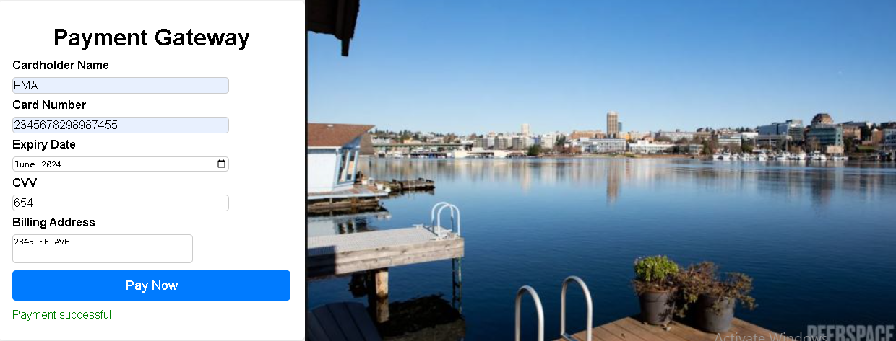

[***4) Small Meeting Space***](http://docs.google.com/Small_Meeting_Space.html) **of Comprehensive Rental Management System (CRMS) Coding**

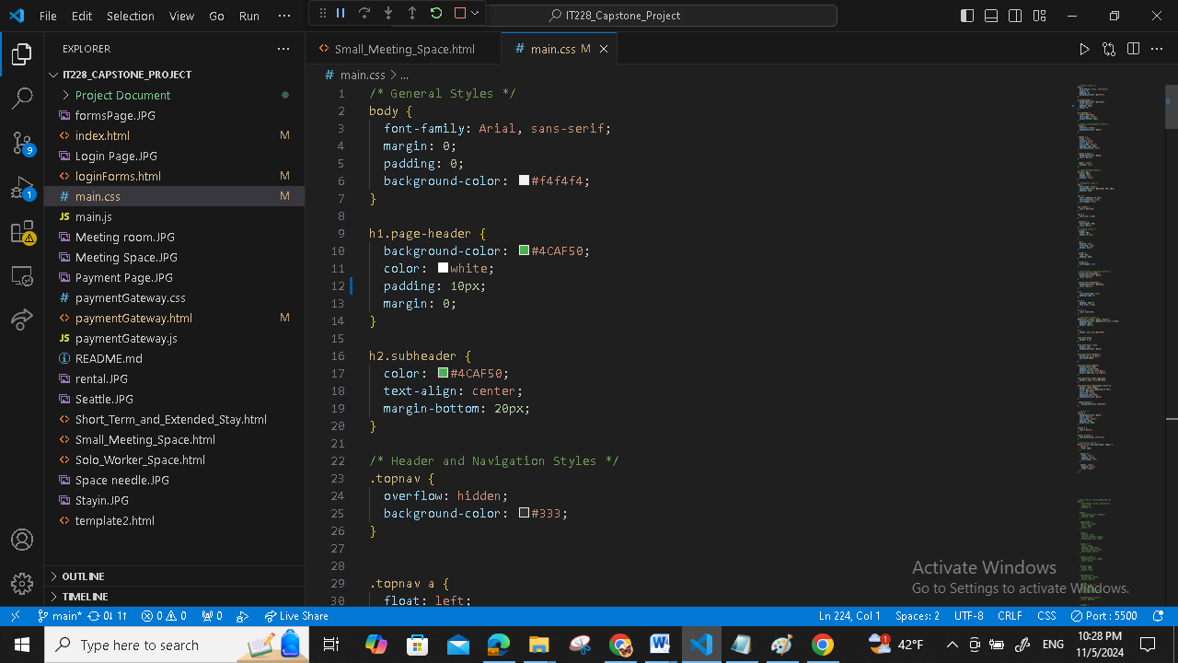

[**Small Meeting Space**](http://docs.google.com/Small_Meeting_Space.html) **screen shoot***f or* **Comprehensive Rental Management System (CRMS)**

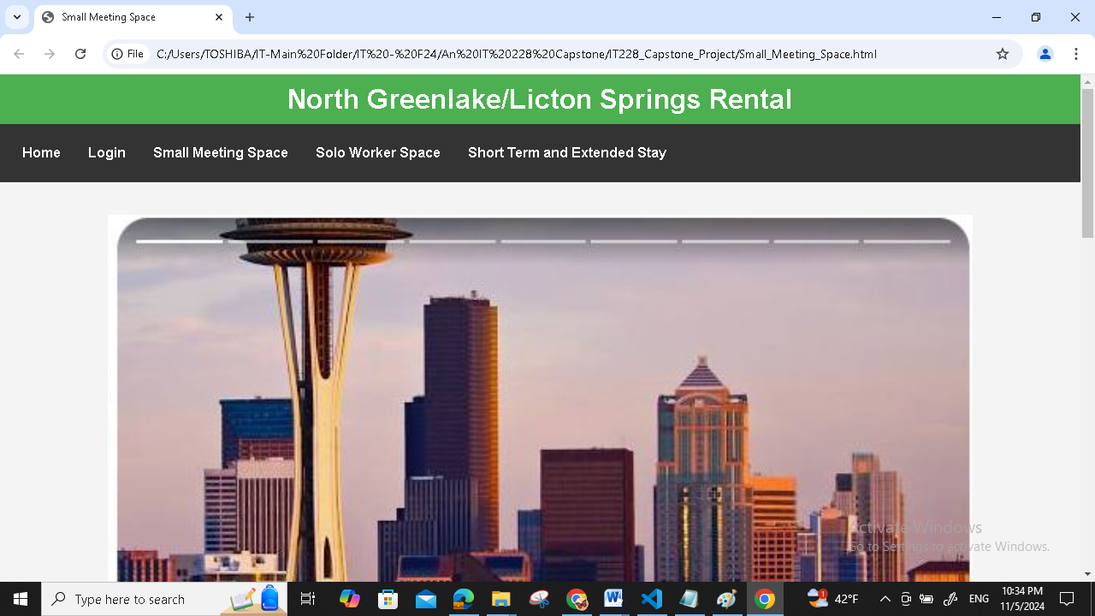

**Website linked to** [**Small Meeting Space**](http://docs.google.com/Small_Meeting_Space.html) **screen shoot***f or* **Comprehensive Rental Management System (CRMS)**

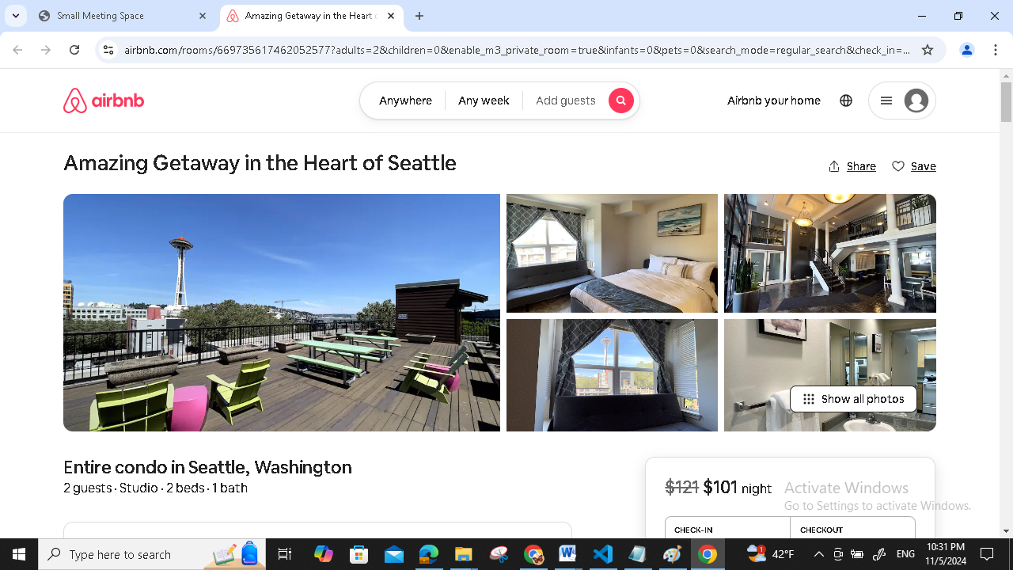

**5) Coding and web page screen shoot for** [***Solo Worker Space***](http://docs.google.com/Solo_Worker_Space.html) **of Comprehensive Rental Management System (CRMS)**

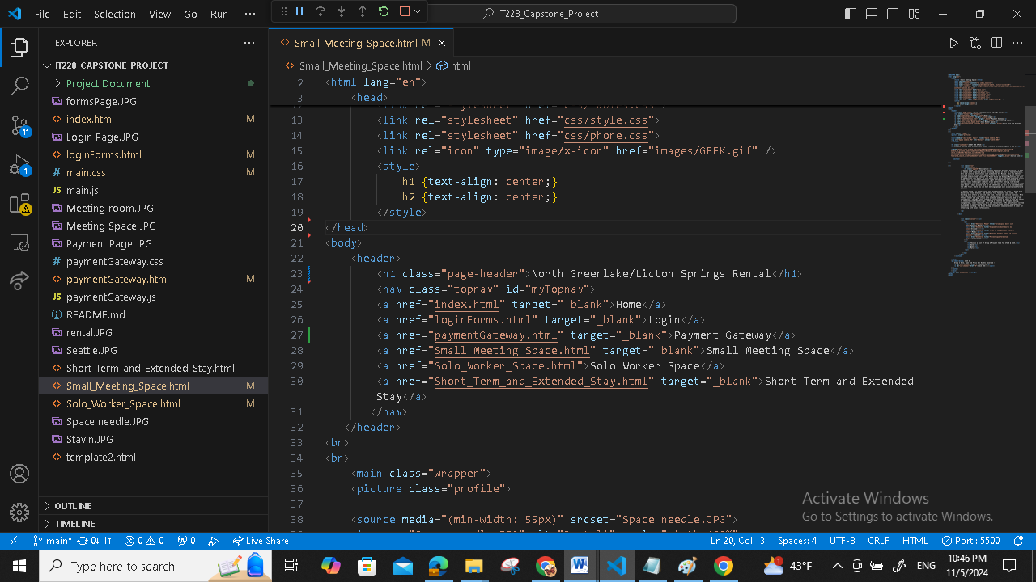 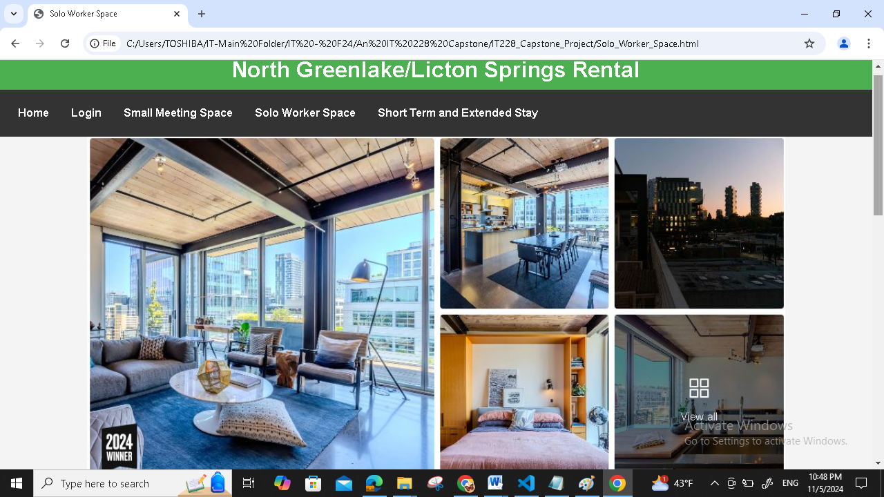

**Website linked to** [***Solo Worker Space***](http://docs.google.com/Solo_Worker_Space.html) **of Comprehensive Rental Management System (CRMS)**

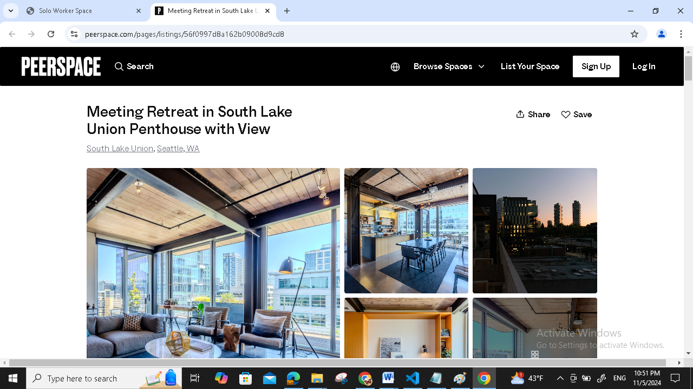

**6) Coding and Screen shoot web page** [***Short Term and Extended Stay***](http://docs.google.com/Short_Term_and_Extended_Stay.html) **of Comprehensive Rental Management System (CRMS)**

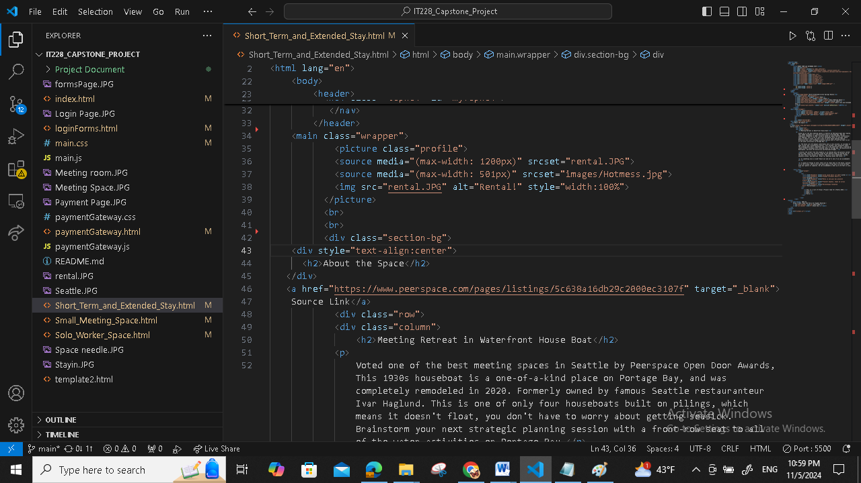 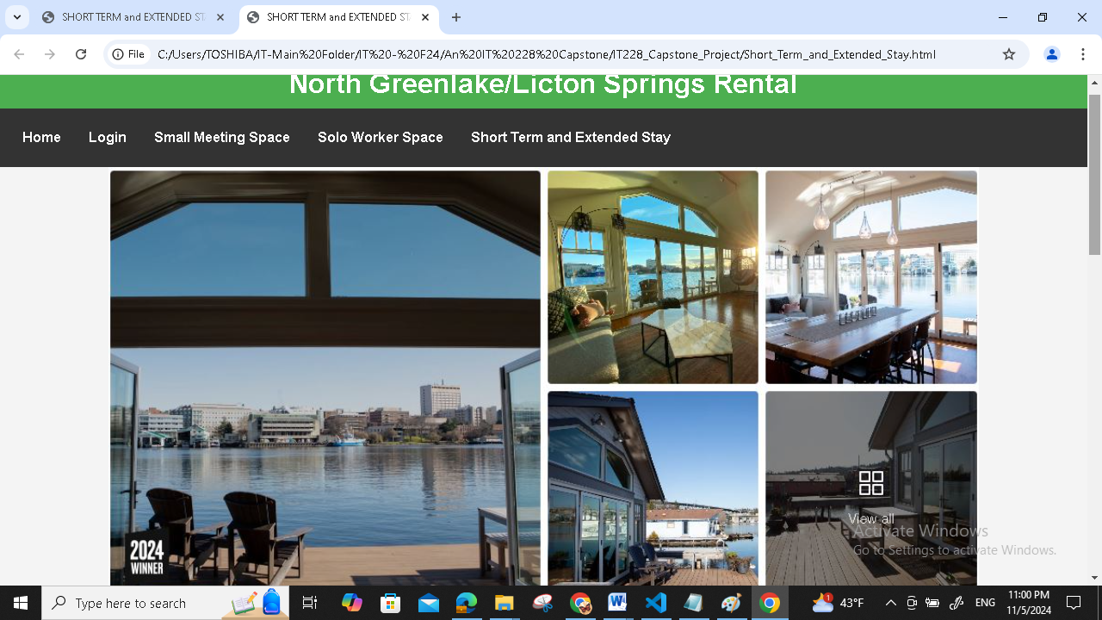

**Website page linked to** [***Short Term and Extended Stay***](http://docs.google.com/Short_Term_and_Extended_Stay.html) **of Comprehensive Rental Management System (CRMS)**

